**TECHNICAL REPORT WRITING FOR CA#2 EXAMINATION**



**NAME**- SAPNADARSHI SINGHA

**STREAM**- COMPUTER SCIENCE AND BUSINESS SYSTEM

**YEAR**- SECOND (FOURTH SEMESTER)

**ROLL NUMBER**- 18731122014

**SUBJECT NAME**- BIOLOGY

**SUBJECT CODE-** BSC 401

**REGISTRATION NO**- 221870110095

**SESSION-** 2022-2026

**DATE OF SUBMISSON**- 17/03/2024

**TOPIC-** ABO BLOOD GROUP DETERMINATION

CONTENT PAGE

|  |  |  |
| --- | --- | --- |
| SI NO. | CONTENT | PAGE NO |
|  | TABLE OF CONTENT | 2 |
|  | ABSTRACT | 3 |
|  | INTRODUCTION | 4 |
|  | ANALYSIS | 5-8 |
|  | CONCLUSION | 9 |
|  | REFERENCE | 10 |

TABLE OF DIAGRAM

|  |  |  |
| --- | --- | --- |
| SI NO. | DIAGRAMS | PAGE |
| 1 | DIAGRAM 1- TYPES OF BLOOD GROUP | 4 |
| 2 | DIAGRAM 2- BLOOD GROUP GENERATION (ABO) | 5 |
| 3 | DIAGRAM 3-BLOOD GROUP GENERATION (POSITIVE OR NEGATIVE) | 6 |
| 4 | DIAGRAM 4- STRUCTUE OF BLOOD CELLS | 8 |

ABSTRACT

The ABO blood group system is still a cornerstone in transfusion medicine and genetics, representing an important aspect of human biology. Determining an individual's blood type within this system requires complex molecular interactions, immunological responses, and clinical implications. This abstract delves into the nuances of ABO blood group determination, including its historical context, genetic basis, laboratory methodologies, and clinical implications.

The clinical implications of ABO blood group determination are multifaceted. In transfusion medicine, accurate blood typing is critical for avoiding haemolytic transfusion reactions caused by incompatible blood transfusions. Furthermore, ABO blood group compatibility is critical in organ transplantation to reduce the likelihood of graft rejection. Aside from transfusion and transplantation, ABO blood group status has been linked to a variety of disease susceptibilities and associations, including cardiovascular disorders and infectious diseases.

INTRODUCTION

The ABO blood group system is a fundamental and widely recognized classification in human biology, with applications in medicine, forensics, and anthropology. ABO blood group determination, based on Karl Landsteiner's pioneering discoveries in the early twentieth century, distinguishes between the presence and absence of specific antigens on the surface of red blood cells, laying the groundwork for understanding blood compatibility, transfusion medicine, and genetic inheritance patterns.

Landsteiner's groundbreaking blood transfusion experiments were instrumental in elucidating the ABO blood group system throughout history. In 1900, Landsteiner observed agglutination reactions when mixing blood from different people, prompting him to identify distinct blood types based on the presence of agglutinogens, now known as A and B antigens. Landsteiner's meticulous investigations paved the way for subsequent advances in blood typing methods and understanding of human blood group genetics.

The ABO gene serves as the genetic basis for the ABO blood group system. This gene encodes glycosyltransferase enzymes that add specific carbohydrate molecules to the surface of red blood cells, indicating the presence of A and B antigens. The ABO gene has three main alleles: A, B, and O. Individuals with the A allele express A antigens, those with the B allele express B antigens, and those homozygous for the O allele lack both A and B antigens. The combination of these alleles determines an individual's blood type, resulting in four major ABO blood groups: A, B, AB, and O.

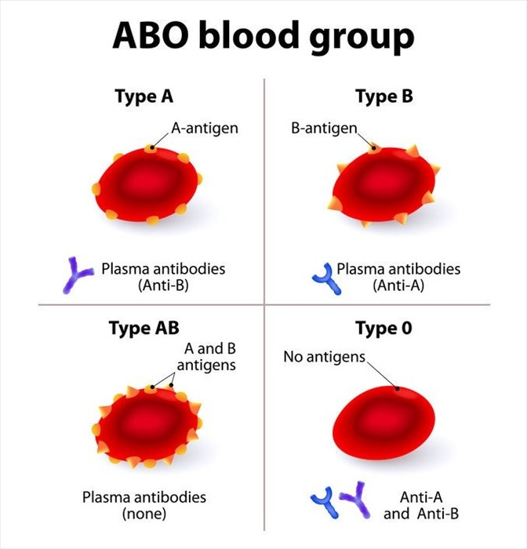

ANALYSIS

**ABO BLOOD GROUP DETERMINATION**

* *Step 1*: Determination Of Blood Group Type (A, B, AB, O)

1. Each parent contributes one Gamete to their child.
2. The possible alleles for the ABO blood group system are A, B, and O.
3. A and B Gametes are co-dominant, while O Gamete is recessive.

Therefore, the possible combinations of alleles that the child could inherit from each parent are:

Mother (IBi) + Father (IAi):

From the mother: IB (Gamete B) & From the father: IA (Gamete B)

So, the child could inherit either Gamete A or Gamete B from each parent, resulting in the following possible genotypes for the child:

IA (Blood Type A)

IAIB (Blood Type AB)

IB (Blood Type B)

ii (Blood Type O)

Therefore, the child's blood type could be either A or B, depending on which allele they inherit from each parent.

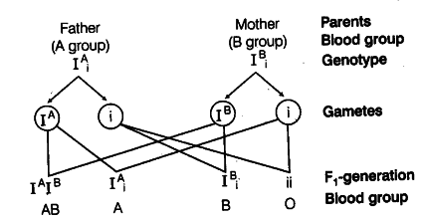

* *Step 2*: Determining whether a person's blood type is positive or negative (e.g., A+, B-, AB+, O-)

Test for the Rh Factor: After determining the ABO blood type, conduct a separate test to determine the presence or absence of the Rh antigen (Rh D) on red blood cells.   
  
If the Rh antigen is present, the blood type is classified as Rh-positive (A+, B+, AB+, O+).   
The absence of the Rh antigen indicates that the blood type is Rh-negative.

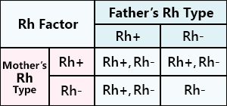

The correct determination of an individual's ABO blood group is critical for many medical procedures, including blood transfusions, organ transplantation, and prenatal care. Several laboratory methods for accurately identifying ABO blood groups have been developed over the years. These methods differ in complexity, sensitivity, and applicability, catering to various clinical and research requirements.

* METHODOLOGIES FOR BLOOD GROUP DETERMINATION

A variety of laboratory techniques for determining ABO blood groups have been developed, each with its own set of benefits and uses. Traditional methods, such as Landsteiner's agglutination assays with specific antisera, paved the way for modern approaches.

1. **Agglutination Methods:**
2. Tube Agglutination: One of the first methods developed for ABO blood typing, tube agglutination is based on the visible clumping (agglutination) of red blood cells when mixed with specific antisera containing antibodies against A and B antigens. The reaction can be seen macroscopically or microscopically, and the presence or absence of agglutination indicates an individual's blood type.
3. Slide Agglutination: Similar to tube agglutination, slide agglutination is the process of mixing red blood cells with antisera on a glass slide. The presence of agglutination is visible under a microscope, allowing for rapid blood typing in the clinical setting.
4. Solid phase Agglutination: Solid phase agglutination assays use microplates or other solid surfaces coated with ABO-specific antibodies. Patient blood samples are added to the wells, and agglutination is detected using a variety of methods, including colorimetric and chemiluminescent assays. Solid phase agglutination provides high throughput and is easily automated for large-scale blood typing.
5. Gel Column Agglutination: This method uses gel microspheres coated with antibodies to A and B antigens. When the patient's blood is added to the gel column, agglutination occurs when the red blood cells react with the antibodies. Gel column agglutination has several advantages over traditional methods, including faster results, automation potential, and increased sensitivity.
6. **Flow Cytometry:**

Flow cytometry-based methods detect fluorescently labelled antibodies that bind to ABO antigens on the surface of red blood cells. Flow cytometry, which analyses the fluorescence patterns of individual cells, enables rapid and accurate blood typing, especially in blood banks and high-volume laboratories. This method is highly sensitive and can distinguish between weak and strong antigen expression.

1. **Molecular Typing**:

Molecular typing, including PCR and DNA sequencing, provides genetic information for ABO blood groups. PCR-based assays amplify specific regions of the ABO gene, allowing for the detection of allelic variations linked to different blood types. DNA sequencing enables accurate determination of ABO alleles and rare variants.

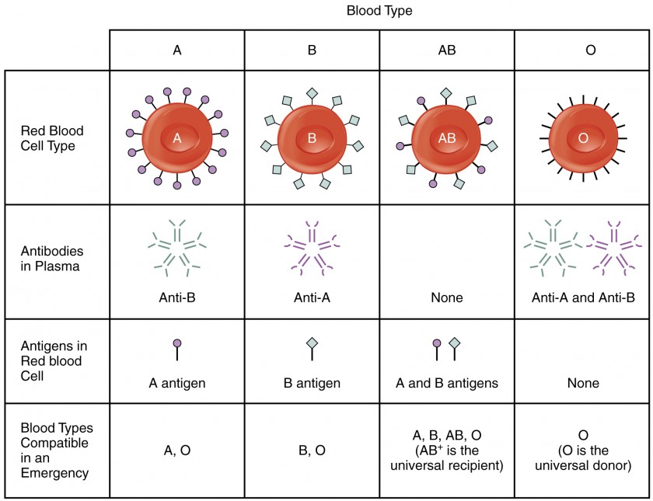

* CLINICAL IMPORTANCE OF BLOOD GROUP DETERMINATION

1. The clinical significance of ABO blood group determination goes well beyond transfusion compatibility. In transfusion medicine, accurate blood typing is critical to avoiding adverse reactions, such as haemolytic transfusion reactions, which occur when incompatible blood types are transfused. ABO compatibility is also important in organ transplantation, as mismatched blood groups can cause immune responses that lead to graft rejection. Furthermore, ABO blood group status has been linked to a variety of disease susceptibilities and outcomes, including cardiovascular disorders, infectious diseases, and cancer, though the mechanisms underlying these associations are still being studied.
2. In forensic science and anthropology, ABO blood group determination is an important tool for identifying individuals and understanding population genetics. Blood typing can help with criminal investigations, paternity testing, and mass disaster victim identification by providing unique genetic markers for each person. Furthermore, studying the distribution of ABO blood groups in different populations provides information about human migration patterns, evolutionary history, and genetic diversity.

CONCLUSION

To summarize, the significance of ABO blood group determination extends far beyond its historical roots, encompassing a wide range of clinical, forensic, and anthropological applications. As we gain a better understanding of the genetic and immunological underpinnings of the ABO blood group system, laboratory methodologies will improve and clinical implications will be investigated, shaping the landscape of transfusion medicine, personalized healthcare, and population genetics.

Furthermore, the ABO blood group system provides a window into our evolutionary history, reflecting the intricate interplay of genetics, migration patterns, and environmental pressures. Researchers learn a lot about human diversity, ancestry, and adaptation by studying the distribution of blood types across different populations.

In essence, the study of ABO blood group determination emphasizes its importance as a foundation of modern medicine and genetics. Through collaboration, innovation, and a commitment to scientific inquiry, we can continue to unravel the complexities of this system and harness its potential to benefit humanity for future generations.

REFERENCE

1. <https://fairfaxcryobank.com/>
2. <https://stock.adobe.com/> , <https://www.geeksforgeeks.org/>
3. <http://nbtc.naco.gov.in/>
4. <https://surendranathcollege.ac.in/new/upload/SUBHADRA_ROYABO%20blood%20grouping2020-03-27Practical%20-ABO%20blood%20grouping-converted.pdf>